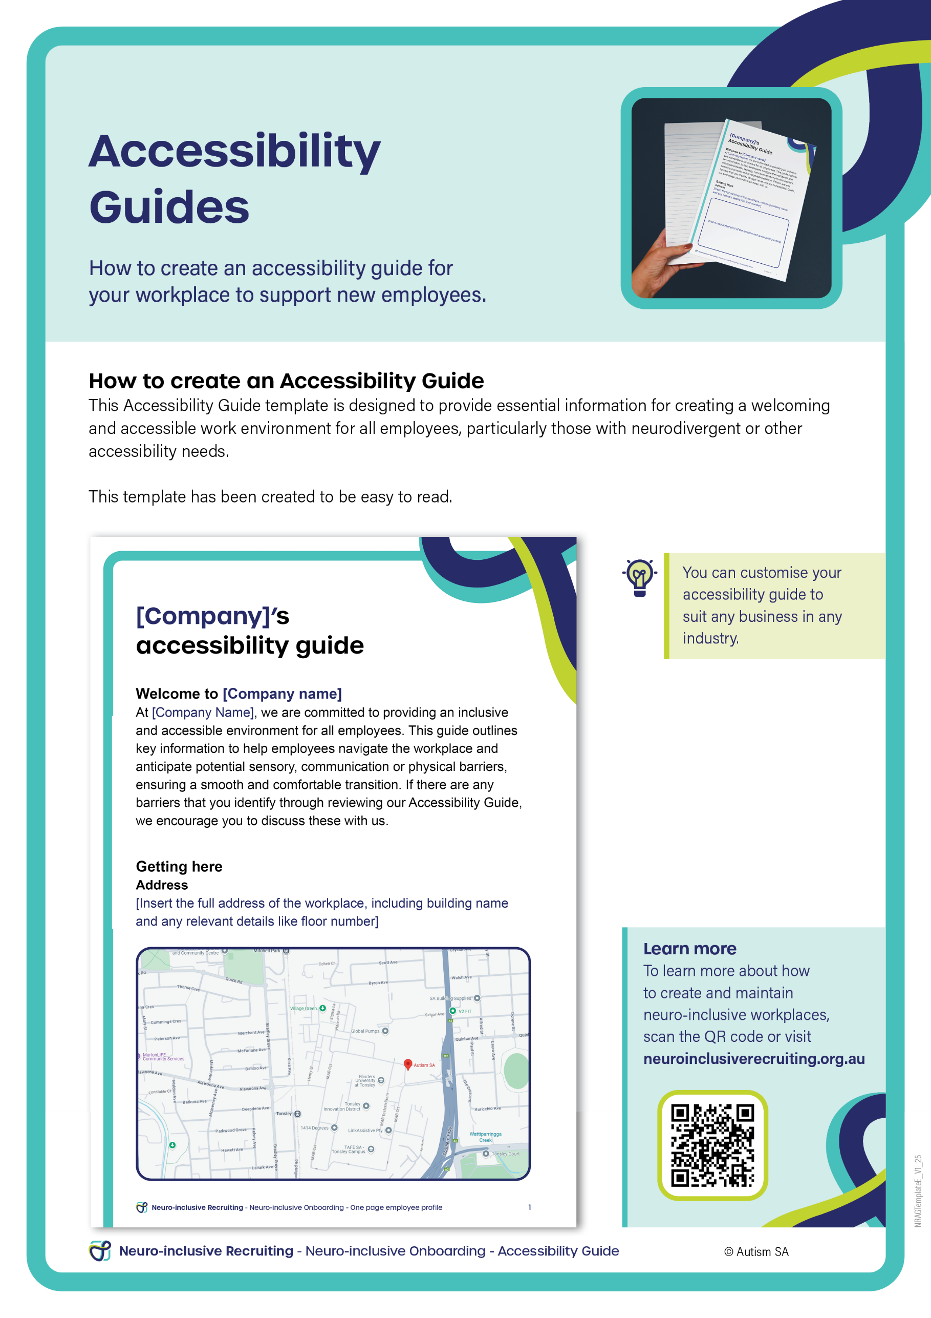

**[Company]’s**

**Accessibility Guide**

Welcome to [Company name]

At [Company Name], we are committed to providing an inclusive and accessible environment for all employees. This guide outlines key information to help employees navigate the workplace and anticipate potential sensory, communication or physical barriers, ensuring a smooth and comfortable transition. If there are any barriers that you identify through reviewing our Accessibility Guide, we encourage you to discuss these with us.

**Getting here**

**Address**

[Insert the full address of the workplace, including building name and any relevant details like floor number]



[Add caption to image of online maps screenshot]

**Public transport**

[Describe public transport options, including nearby bus stops, train stations, or tram routes.]

[Indicate if there are dedicated taxi or rideshare drop-off zones and their proximity to the building.]

|  |  |
| --- | --- |
| [Add caption to image of transport] | [Add caption to image of transport] |

**Car parking**

[Detail available parking options, including disability parking spaces and the number of available spots.]

[Specify how far parking is from the building entrance and provide directions and photographs.]

|  |  |
| --- | --- |
| A white square with a blue border  AI-generated content may be incorrect.  [Add caption to image of transport] | A white square with a blue border  AI-generated content may be incorrect.  [Add caption to image of transport] |

**Nearby road activity**

[Describe traffic conditions around the building during different times of the day, particularly at peak hours or special events.]

[Highlight quieter entry options for employees looking to avoid busy roads.]

**Workplace layout and facilities**

**Entrances and exits**

[Provide details on the building’s entrances, including any potential barriers like stairs or ramps. Include information on sliding doors or automatic doors if applicable.]

[Specify which entrances are most accessible for individuals using mobility aids like wheelchairs or walking sticks/frames.]

|  |  |
| --- | --- |
| A white square with a blue border  AI-generated content may be incorrect.  [Add caption to image of entrances] | [Add caption to image of exits] |
|  |  |
| A white square with a blue border  AI-generated content may be incorrect.  [Add caption to image of entrances] | [Add caption to image of exits] |

**Accessibility**

[Provide information about wheelchair access, uneven surfaces, or ramps throughout the building.]

[Include photos or diagrams to illustrate accessible routes into the building.]

|  |  |
| --- | --- |
| A white square with a blue border  AI-generated content may be incorrect.  [Add caption to image of entrances] | [Add caption to image of exits] |

|  |  |
| --- | --- |
| A white square with a blue border  AI-generated content may be incorrect.  [Add caption to image of entrances] | [Add caption to image of exits] |
|  |  |

|  |  |
| --- | --- |
| A white square with a blue border  AI-generated content may be incorrect.  [Add caption to image of entrances] | [Add caption to image of exits] |
|  |  |

**Map**

[Attach a floor plan or map of the office layout, marking important areas such as exits, restrooms, break rooms, quiet zones, and meeting spaces.]



[Add caption to map]

**Sensory details**

**Lighting**

[Describe the lighting in different parts of the building, including natural light areas, overhead fluorescent lights, and adjustable lighting options.] [Detail any dimming options available for events or in certain areas, and how lighting changes throughout the day.]

**Noise levels**

[Outline typical noise levels in various areas of the building, including open-plan offices, break rooms, and meeting areas.]

[Highlight quiet areas available for focused work or breaks.]

[Provide information on high-noise zones such as kitchens, copy rooms, or spaces near heavy traffic.]

**Smells**

[List areas where strong smells may be present, such as kitchens, coffee stations, or cleaning areas.] [Describe how smells are managed in certain areas, where spill kits are kept and whether there are fragrance-free zones.]

|  |  |
| --- | --- |
| A white square with a blue border  AI-generated content may be incorrect.  [Add caption to image] | [Add caption to image] |
|  |  |

**Areas**

**Toilets**

[Specify the types of restrooms available (For example, female, gender-neutral, accessible restrooms).]

[Indicate restroom locations and whether they are equipped with hand dryers or hand towel options.]

[Note: if any restrooms are designated as fragrance-free or have low-noise dryers.]

|  |  |
| --- | --- |
| A white square with a blue border  AI-generated content may be incorrect.  [Add caption to image of restrooms] | [Add caption to image of restrooms] |

**Quiet and escape areas**

[Identify quiet areas where employees can go if they feel overwhelmed. These areas should be accessible and well-signposted and photographed.]

|  |  |
| --- | --- |
| A white square with a blue border  AI-generated content may be incorrect.  [Add caption to image of quiet areas] | [Add caption to image of quiet areas] |

**Seating options**

**Seating arrangements**

[Describe the types of seating available, such as cushioned chairs, booths, ergonomic options, and standing desks.]

[Provide details on seating textures, as some employees may be sensitive to certain materials (For example, leather, woven fabrics)]

|  |  |
| --- | --- |
| A white square with a blue border  AI-generated content may be incorrect.  [Add caption to image of seating arrangements] | [Add caption to image of seating arrangements] |

**Workplace flexibility**

[Mention any options for employees to work in quiet areas, open-plan spaces, or private offices depending on their preferences.]

|  |  |
| --- | --- |
| A white square with a blue border  AI-generated content may be incorrect.  [Add caption to image of working areas] | [Add caption to image of working areas] |

**Lunch and break out areas**

**Food and drink areas**

[Describe the layout of the lunch or break areas, including where employees can put food and drinks.]

|  |  |
| --- | --- |
| A white square with a blue border  AI-generated content may be incorrect.  [Add caption to image of food and drink areas] | [Add caption to image of food and drink areas] |

**Communal items**

[Explain which items, such as tea, coffee, and milk, are communal and which items are not.]

**Expectations**

[Describe the expectations around the lunch and breakout areas. For example, if you use a dish, you are expected to wash, dry, and return it. Identify that personal mugs and crockery can be brought from home.]

**Social and event information**

**Crowd levels**

[Explain the social dynamic in the office, including times of day when common areas may be busy.]

[Highlight quieter times or spaces for employees who prefer less interaction.]

**Meeting formats**

[Detail the typical formats of meetings (in-person, virtual, hybrid) and any accommodations available, such as providing agendas in advance or dimming lights during presentations.]

**Neuro-inclusive events**

[If the company offers specific quiet or sensory-friendly events, include details here.]

**Contact Information**

If you have any questions or require additional accommodations or adjustments based on this information, please contact us to discuss:

**Name:** [People and Culture contact name]

**Phone Number:** [Insert phone number]

**Email:** [Insert email address]

**Text Number (if applicable):** [Insert number]